2020-2021 Report for the Masters of Counseling (MACO) program at Gordon-Conwell Theological Seminary—Hamilton

Program faculty and staff review up to eleven metrics annually to evaluate the MACO program.
- Demographics of MACO applicants and entering students survey results
- Demographics of MACO current students and current student survey results
- Annual MACO Diversity survey results
- Annual evaluation of current and graduating MACO students
- Graduation rates
- Graduating students exit interviews
- Demographics of MACO graduating students and graduating student survey results
- Results from one annual study
- Results from the GCTS alumni survey
- Results from the MACO alumni survey
- Key Performance Indicators (KPIs)

Recommended changes to the program are noted at the end of the report.

1. Enrollment data: demographics of MACO applicants and results from Entering Student Survey

Table 1. Demographics of MACO applicants: number (percentage)
2015 US Census race/ethnicity (percentage of total US population) | 2015-2016 MACO applicants | 2016-2017 MACO applicants | 2017-2018 MACO applicants | 2018-2019 MACO applicants | 2019-2020 MACO applicants | 2020-2021 MACO applicants
American Indian or Alaskan Native (1.2%) | 0 | 0 | 0 | 0 | 0 | 0
Asian (5.6%) | 6 (14%) | 4 (9%) | 6 (11%) | 2 (5%) | 4 (5%) | 4 (9%)
Black or African American (13.3%) | 1 (2%) | 2 (4%) | 3 (5%) | 1 (3%) | 5 (6%) | 5 (11%)
Hispanic / Latinx (17.6%) | 2 (5%) | 0 | 1 (2%) | 1 (3%) | 10 (12%) | 5 (11%)
Native Hawaiian or Other Pacific Islander (0.2%) | 0 | 0 | 0 | 0 | 0 | 0
White not Hispanic (61.6%) | 17 (39%) | 9 (20%) | 12 (21%) | 12 (31%) | 19 (22%) | 9 (21%)
Two or more races (2.6%) | 0 | 0 | 0 | 0 | 3 (4%) | 0
Non-resident alien | 4 (9%) | 8 (18%) | 5 (9%) | 14 (36%) | 14 (16%) | 7 (16%)
Undeclared/unknown | 14 (32%) | 22 (49%) | 29 (52%) | 3 (8%) | 31 (36%) | 14 (32%)
Female (50.8%) | 24 (55%) | 26 (58%) | 25 (45%) | 19 (49%) | 49 (57%) | 28 (64%)
Male (49.2%) | 20 (45%) | 19 (42%) | 31 (55%) | 18 (46%) | 37 (43%) | 16 (36%)
TOTAL | 44 applicants | 45 applicants | 56 applicants | 39 applicants | 86 applicants | 44 applicants
US Census data are July 2015 Census data from https://www.census.gov/quickfacts/table/PST045215/00 Retrieved July 22, 2016

From these demographics, the MACO program attracted fewer Black/African American and Hispanic applicants compared to the population, although about a third of applicants did not declare their race/ethnicity, so great caution is needed in interpreting these data. The number of diverse applicants is trending in a direction that allows the program to meet its objective to be a diverse program. The strength of the MACO program is in attracting international students. In terms of gender, more MACO applicants identify as female.

Twenty-five entering students completed the 2020 Entering Student Survey. The majority of entering students (n=21, 84%) are in the 20-29-year-old age range. Three are in the 30-39 and one in the 40-49-year-old age range. Seventy-six percent are female. Six (24%) are dual MDIV/MACO degree-seeking students. Most (88%) are U.S. citizens with almost half (n=11, 48%) coming from Massachusetts. Two (8%) consider themselves Hispanic or Latinx, four (16%) black or African American, six (24%) Asian, and 15 (60%) white. Fifteen (60%) are single. Eighteen (72%) completed their undergraduate degree in the last five years. Most made the decision to go to seminary while working (n=12, 48%). They sought theological education because of the opportunity to study (n=22, 88%), the anticipation of spiritual growth (n=21, 84%) or the intellectual interest in religious / theological questions (n=20, 80%). They chose GCTS because of the curriculum (n=20, 80%), the quality of the faculty (n=20, 80%) and staff (n=19, 76%), and the spiritual atmosphere (n=19, 76%). GCTS favorably compared to the other theological education opportunities because of the academic reputation of the school (n=19, 76%). Half (n=12, 50%) only considered GCTS but six (25%) considered Fuller and four (17%) considered Denver. The largest obstacles were the cost of education at GCTS (n=15, 68%) and relocation (n=10, 45%). Most heard about GCTS from a GCTS graduate (n-13, 52%), from the web site (n=8, 32%), their pastor (n=6, 24%), or a friend (n=5, 20%). The majority (n=15, 63%) find residential / on campus learning to be the most appealing.
About half are bringing in educational debt of $10K-$19,999 (24%) to $20K-$29,999 (24%). About a third (32%) do not commute, about a fourth (24%) commute less than half an hour to school, and a fifth (20%) commute 1-2 hours to school. About a fourth (24%) plan to work at a paying job 10-15 hours/week (24%), 21-30 hours/week (24%) and 31 or more hours (24%). A majority (n=23, 92%) plan to be licensed as a counselor or clergy.

2. Demographics of current MACO students and results from Current Student Survey

Table 2. Demographics of current MACO students: number (percentage)
2015 US Census race/ethnicity (percentage of total US population) | 2015-2016 MACO current students | 2016-2017 MACO current students | 2017-2018 MACO current students | 2018-2019 MACO current students | 2019-2020 MACO current students | 2020-2021 MACO current students
American Indian or Alaskan Native (1.2%) | 0 | 0 | 0 | 0 | 0 | 0
Asian (5.6%) | 15 (23%) | 11 (16%) | 15 (21%) | 12 (15%) | 10 (17%) | 14 (20%)
Black or African American (13.3%) | 4 (6%) | 5 (8%) | 7 (10%) | 3 (4%) | 3 (5%) | 4 (6%)
Hispanic / Latinx (17.6%) | 3 (5%) | 2 (3%) | 3 (4%) | 1 (1%) | 8 (14%) | 10 (15%)
Native Hawaiian or Other Pacific Islander (0.2%) | 0 | 0 | 0 | 0 | 0 | 0
White not Hispanic (61.6%) | 35 (53%) | 35 (52%) | 30 (43%) | 43 (54%) | 25 (42%) | 27 (39%)
Two or more races (2.6%) | 0 | 0 | 0 | 1 (1%) | 2 (3%) | 2 (3%)
Non-resident alien | 8 (12%) | 8 (12%) | 9 (13%) | 12 (15%) | 7 (12%) | 7 (10%)
Undeclared/unknown | 1 (2%) | 6 (9%) | 6 (9%) | 6 (8%) | 4 (7%) | 5 (7%)
Female (50.8%) | 44 (67%) | 39 (58%) | 43 (61%) | 49 (62%) | 41 (70%) | 49 (71%)
Male (49.2%) | 22 (33%) | 28 (42%) | 27 (39%) | 30 (38%) | 18 (31%) | 20 (29%)
TOTAL | 66 current students | 67 current students | 70 current students | 79 current students | 59 current students | 69 current students
US Census data are July 2015 Census data from https://www.census.gov/quickfacts/table/PST045215/00 Retrieved July 22, 2016

From these demographics, the MACO program enrolled more Asian and fewer Black/African American applicants compared to the population. The number of enrolled Hispanic/Latinx students is close to the population. The number of diverse enrollees is trending in a direction that allows the program to meet its objective to be a diverse program. The strength of the MACO program is in enrolling international students. In terms of gender, more MACO enrollees identify as female.

The Current Student Survey was not sent to GCTS students in the last year because of the pandemic.

3. Annual MACO Diversity survey
The SurveyMonkey link to the Annual MACO Diversity survey was emailed to MACO students, faculty and staff on 3/1/21 and 4/19/21. 23 total responses were collected (about a 25% response rate, a lower response rate compared to last year perhaps related to a long pandemic).

Respondents were all students. Twenty-one were U.S. citizens. For seven, English is not their native language. Fourteen identify as female. They identified as White or Caucasian (n=13), Asian or Asian American (n=4), Hispanic or Lantinx (n=3), African American or Black or of African Descent (n=1) and International (n=1). No respondents identified as a sexual minority. One respondent identified as having a mental health condition that meets ADA criteria. The denominations most represented were non-denominational (n=5), Presbyterian (n=3) and Baptist (n=3).

Respondents reported that MACO students have made disparaging or insensitive remarks frequently about persons of a particular racial/ethnic background (n=1), or about men (n=1). They have made disparaging or insensitive remarks often about LGBTQI persons (n=1), women (n=1), persons of a particular socioeconomic background (n=1), or persons of a particular religious / denominational background (n=1).

Respondents reported that MACO faculty or teaching assistants have frequently made disparaging or insensitive remarks about women (n=1) or often about LGBTQ+ persons (n=1), non-native English speaking persons (n=1), men (n=1), and a person’s age (n=1).

Respondents reported that a MACO staff person or administrator have frequently made disparaging or insensitive remarks about women (n=1) or men (n=1) or often about LGBTQ+ persons (n=1).

Respondents reported feeling discriminated against or harassed in a MACO class or at a MACO event often because of their religious / denominational affiliation (n=1) or because of their race / ethnicity (n=1). Discrimination or harassment was expressed through ignoring (n=3), glances (n=2), or verbal comments (n=2); these happened in a classroom (n=3) or via the internet [Canvas or email] (n=2) or while working at a campus job (n=1). The source of the discrimination or harassment was students (n=3), or staff (n=1), or neighbors in the area (n=1).

Respondents disagreed or strongly disagreed that the MACO program is adequately addressing issues on campus related to Language barriers (e.g., accent, vocabulary, etc.) (n=5), Religious / denominational differences (n=4), Disability or ableism (n=4), Age or ageism (n=4), or Race, racism or ethnocentrism (n=3). Respondents disagree or strongly disagree that The curriculum adequately represents the contributions of a variety of groups of people (n=4). All 23 respondents reported being very likely or somewhat likely to Challenge others on racial / ethnic / sexually derogatory comments, Get to know people from different cultures and groups, Refuse to participate in comments or jokes that are derogatory to any group or culture or gender, Refuse to repeat a derogatory comment or joke about another group or culture or gender, and Refuse to forward email messages or re=post comments or jokes that are derogatory to another group or culture or gender.

Respondents either disagreed or strongly disagreed that they are satisfied with their MACO experience / environment regarding diversity in the MACO program (n=2), that people of different races and cultures are accepted socially in the MACO program (n=2), and that the people of different socioeconomic backgrounds are accepted socially in the MACO program (n=2.

Four respondents of color reported they do not feel that they have received adequate support in the MACO program. Three have feared for their physical safety on the campus. And two have had someone assume that they were admitted / employed because they are a person of color. Four have felt isolated or left out in group work. Four have felt they were expected to speak on behalf of all members of their race or ethnicity. Three have felt singled out for their particular group when issues of race or ethnicity arose.

One respondent with a mental health condition that meets ADA criteria reported receiving adequate support from the MACO program as a person with a disability.

Respondents said they would like additional training to increase their cultural competence with LGBTQ+ persons (n=14), non-English speakers (n=12), people of a particular socio-economic background (n=12), people with a disability (n=12), and people of a particular racial or ethnic background (n=11).

4. Annual reviews of current students

MACO students are reviewed once annually, either for an Annual or Summative evaluation. For the Annual reviews, each student’s progress in the program is evaluated by the program faculty. Students’ development is deemed either “satisfactory progress,” “remediation,” “probation,” “voluntary resignation,” or “dismissal from the program.”

The faculty met April 12, 2021 for summative evaluation of May 2021 graduates. All graduates were deemed to have met criteria for graduation.

Two faculty met on August 28, 2021 and reviewed all Fall 2021 graduates and current MACO students. All students were deemed to be making satisfactory progress in the program, while one student is on a remediation plan.

5. Graduation rate
The years represent cohort years, the years in which the student started their program. For example, the 2011-12 cohort represents anyone who started the program in the 2011-12 academic year. That cohort’s seven-year graduation percentage would be looking at anyone who had graduated before or during the 2017-18 academic year (which would have been their seventh year in the program), anyone who entered in 2011-12 and graduated by May 2018.

Cohort Year | Graduation Rate
2014-15  2013-14 | 87  100
2012-13 | 82.6
2011-12 | 84.4
2010-11 | 58.6
2009-10 | 66.7
5 Year Average (2011-15) | 82.52

6. Exit interviews with graduates
Four graduating students participated in 20 minute interviews with three MACO faculty. Graduating students reported the following program strengths.
- MACO prepares its students well clinically.
- Three had jobs already.

Graduating students suggested the following improvements to the program.
- More opportunities to take electives. How the courses are laid out makes it difficult for some students to take electives.
- More availability of professors who were perceived as not being available for relationships outside of classrooms.

7. Demographics of graduating MACO students and results from Graduating Student Survey.

Table 3. Demographics of MACO graduates: number (percentage)
2015 US Census race/ethnicity (percentage of total US population) | 2015-2016 MACO graduates | 2016-2017 MACO graduates | 2017-2018 MACO graduates | 2018-2019 MACO graduates | 2019-20 MACO graduates | 2020-21 MACO graduates
American Indian or Alaskan Native (1.2%) | 0 | 0 | 0 | 0 | 0 | 0
Asian (5.6%) | 6 (32%) | 3 (14%) | 3 (19%) | 4 (18%) | 2 (11%) | 2 (11%)
Black or African American (13.3%) | 1 (5%) | 2 (9%) | 1 (6%) | 0 | 2 (11%) | 2 (11%)
Hispanic (17.6%) | 1 (5%) | 2 (9%) | 1 (6%) | 1 (5%) | 0 | 0
Native Hawaiian or Other Pacific Islander (0.2%) | 0 | 0 | 0 | 0 | 0 | 0
White not Hispanic (61.6%) | 8 (42%) | 11 (50%) | 9 (56%) | 11 (50%) | 11 (61%) | 11 (61%)
Two or more races (2.6%) | 0 | 0 | 0 | 0 | 0 | 0
Non-resident alien | 2 (11%) | 3 (14%) | 2 (13%) | 3 (14%) | 2 (11%) | 2 (11%)
Undeclared/unknown | 1 (5%) | 1 (5%) | 0 | 3 (14%) | 1 (6%) | 1 (6%)
Female (50.8%) | 13 (68%) | 16 (73%) | 12 (75%) | 14 (64%) | 10 (56%) | 10 (56%)
Male (49.2%) | 6 (32%) | 6 (27%) | 4 (25%) | 8 (36%) | 8 (44%) | 8 (44%)
TOTAL | 19 graduates | 22 graduates | 16 graduates | 22 graduates | 18 graduates | 18 graduates
US Census data are July 2015 Census data from https://www.census.gov/quickfacts/table/PST045215/00 Retrieved July 22, 2016

From these demographics, the MACO program graduated a number of students who will contribute to diverse communities.

Six graduating students completed the Graduating Student Survey. One of the six respondents was an MDIV/MACO dual degree graduate. Six respondents were very satisfied with maintenance of the GCTS grounds and one respondent was either very or somewhat dissatisfied with technology aspects like web site navigation, CAMS student portal, information technology or help desk support. Five respondents were very satisfied with faculty credentials, faculty as role models and class size. One respondent was either very or somewhat dissatisfied with availability of course offerings, internship opportunities and Pierce center activities. The two aspects of the MACO program that respondents were most satisfied with were faculty (n-5, 83%) and collegiality with peers (n=5, 83%). While most respondents agreed or somewhat agreed that course instruction reflects the diversity of the national and global church in racial/ethnic diversity, gender diversity and theological diversity, one respondent disagreed. Respondents suggested that GCTS’ number one priority should be on international student services (n=1), faculty availability (n=1), Semlink courses (n=2), placement services (n=1) and curriculum (n=1). They rated as the most influential in their educational experience faculty availability (n=3), faculty as role models (n=2), and curriculum (n=1). Two respondents had been offered a position by the time of graduation.

8. One study per year
This year the MACO team reviewed metrics related to the learning environment including:
- Total student FTE: 64.65
- 27% of MACO Hamilton students are dual degree.
- With three full time faculty and four adjuncts, Student-to-Faculty ratio for MACO Hamilton in 2020-21 was 9.122
- The average class size for MACO Hamilton in 2020-2021 was 25.8 students.
- Thirty-five students have accepted entrance into MACO Hamilton for Fall 2021 and five more are on the waiting list.
The MACO team will bring the following metrics to the Division of Practical Theology for discussion on September 13, 2021.

9. Results from Alumni Survey
The Alumni Survey was not sent to GCTS graduates in the last year due to the pandemic.

10. Results from MACO graduate survey
In the summer of 2021, 13 MACO graduates from 2010 to 2021 responded to a brief 10-item survey. 77 percent (n=10) were female. The majority (77%, n=10) got their first counseling job within a year of graduation with almost half (46%, n=6) having a job before graduation.

About one fourth of respondents (23%, n=3) were not planning to be licensed because their career goals did not require licensure. Of the rest, nine (90%) have obtained a mental health counseling license (with one also having obtained a license in marriage and family therapy). Of the eight who attempted the licensing exam, seven passed on their first attempt and one passed on their second attempt.

Respondents made the following suggested improvements to the program: teach “a broader range of diagnoses” including spectrum disorders, eating disorders and attachment disorders, more training on private practice, on documentation such as CANS, and on LGBTQ issues. Additional suggestions are to help graduates prepare for the licensing exam and to provide more scholarship opportunities for MACO students so that practicing clinically is a potential career goal for graduates. More help with getting a practicum/internship placement was recommended. Respondents praised the program for good clinical training and integration.

11. Key Performance Indicators
For the 2020 program evaluation, program faculty and the program administrator met August 28, 2021 to review Key Performance Indicators (KPIs). The program goal is for 80% of students to earn an 80% or higher on the KPI.
KPI | Assignments assessing KPI | Percent of students earning an 80% or higher on the KPI
KPI 1  Professional counseling orientation and ethical practice  Students will know “ethical standards of professional counseling organizations and credentialing bodies, and” apply “ethical and legal considerations in professional counseling” | In CO790, in the student’s first year, faculty evaluates the student’s knowledge of ethical standards and legal considerations with tests.  In CO790, in the student’s first year, faculty evaluates the student’s application of ethical and legal considerations in the ethical dilemma paper.  As the student progresses in the program, faculty evaluates the student’s knowledge and application of ethical and legal considerations in Professional Seminars in the student’s three case presentations. | 97.30% scored 80% or higher. One student scored lower than 80% on at least one of the assignments.
KPI 2  Social and cultural diversity  Students will understand and apply “the impact of spiritual beliefs on clients’ and counselors’ worldviews” | In CO500, in the student’s first year, faculty evaluates the student’s knowledge of the impact of spiritual beliefs on worldviews as reflected in the integration section and references in the final paper.  In CO801 A & B, the capstone course in the program, faculty evaluates the student’s knowledge of the impact of spiritual beliefs on worldviews by three sequential papers through the semester. |  | 100% scored 80% or higher. No students scored lower.
KPI 3  Human growth and development  Students will understand and apply the “biological, neurological, and physiological factors that affect human development, functioning, and behavior” | In CO/SF610, usually in the student’s first year, faculty evaluates the student’s knowledge of factors that affect human development with theories with tests.  In CO/SF610, in the student’s first year, faculty evaluates the student’s application of their knowledge of factors that affect human development with three observations across the lifespan and their autobiography.  In CO611 Theories of Personality, later in the program, faculty evaluates the student’s application of factors that affect human development in the student’s analysis of their personality paper. |  | 95.12% scored 80% or higher. Two students scored lower on at least one of the assignments.
KPI 4  Career development  Students will understand and apply “processes for identifying and using career, avocational, educational, occupational and labor market information resources, technology, and information systems” | In CO740, faculty evaluates the student’s knowledge of processes for identifying and using career and other information with the student’s career self-assessment and career assessment of a non-relative.  In Professional Seminars, as the student progresses in the program, faculty evaluates the student’s knowledge of processes for identifying and using career and other information in discussions on professional development. |  | 89.58% scored 80% or higher. Five students scored lower on at least one of the assignments.
KPI 5  Counseling and helping relationships  Students will understand and apply “essential interviewing, counseling, and case conceptualization skills” | In CO507, in the student’s first year, faculty evaluates the student’s application of their knowledge of counseling skills with semester-long role-plays in triads; video-recording with transcription, analysis and case conceptualization.  In CO735, faculty evaluates the student’s application of their knowledge of counseling skills with four assessment reports through the semester.  In Professional Seminars, as the student progresses in the program, faculty evaluates the student’s application of their knowledge of counseling skills in three case presentations. |  | 98.36% scored 80% or higher. One student scored lower.
KPI 6  Group process  Students will have “direct experiences in which students participate as group members in a small group activity.” | In CO/PC/SF711, faculty ensures the student’s opportunity to directly experience participation in a small group with the small group assignment.  Students are required to seek a practicum or internship placement where s/he is able to lead a group. |  | 100% scored 80% or higher. No students scored lower.
KPI 7  Assessment and testing  Students will understand and apply the “use of assessments for diagnostic and intervention planning purposes” | In CO735, faculty evaluates the student’s knowledge and use of assessments for diagnostic and intervention purposes with four assessment reports.  In CO740, faculty evaluates the student’s knowledge and use of assessments for diagnostic and intervention purposes with the student’s career self-assessment and career assessment of a non-relative. |  | 92.73% scored 80% or higher. Four students scored lower on at least one of the assignments.
KPI 8  Research and program evaluation  Students will understand and apply “the importance of research in advancing the counseling profession, including how to critique research to inform counseling practice” | In CO500, in the student’s first year, faculty evaluates the student’s use of research and references in the final paper.  In CO699, which students take later in the program, faculty evaluates the student’s use of up-to-date peer reviewed resources in the literature review of the qualitative project (either an individual or a program evaluation project) and of the poster presentation of a quantitative survey project.  In Professional Seminars, as the student progresses in the program, faculty evaluates the student’s use of evidence-based counseling practices in three case presentations. |  | 100% scored 80% or higher. No students scored lower.
KPI 9  Clinical Mental Health Counseling  Students will know and apply the diagnostic process, including differential diagnosis and the use of current diagnostic classification systems, including the Diagnostic and Statistical Manual of Mental Disorders (DSM) and the International Classification of Diseases (ICD) | In CO710, usually in the student’s first year, faculty evaluates the student’s formulation and diagnostic process in two cases on the exam.  In CO735, faculty evaluates the student’s knowledge and use of assessments for diagnostic and intervention purposes with four assessment reports.  In Professional Seminars, as the student progresses in the program, faculty evaluates the student’s knowledge and application of DSM diagnoses in three case presentations. |  | 98.18% scored 80% or higher. One student scored lower on at least one of the assignments.

Program Improvements
MACO faculty and staff met on August 28, 2021 to review the program metrics. Based on the review, they suggested the following program improvements and a timeline for implementing the improvements. Faculty and staff approved the following plan on September 13, 2021.

Gaps | Program improvements and timeline
- Are graduated students omitted from the KPI database? | The program director began working with IT in September 2021 so that graduated students are omitted from the KPI database by the end of fall semester 2021.
- MACO has met its KPI benchmarks for four consecutive years since beginning to track these in 2018. As a result of the program’s success, the program decided in its meeting 4/13/20 to require graduating students to take the Counselor Preparation Comprehensive Examination (CPCE). Results of the CPCE will allow the MACO program to have a more objective view of the knowledge level of its students across all core curricular areas. | Due to the pandemic no students completed the CPCE last year. Graduating students this year will meet with the program director September 24, 2021 12pm-1pm to receive all the details about how to prepare for and complete this requirement. Students will take the CPCE as an “anywhere proctored” exam by May 1, 2022.
- In order to provide students with another avenue for exploring their counselor identity, the program phased out Psi Chi and phased in Chi Sigma Iota as “Chi Alpha Omega.” | MACO became an approved chapter of Chi Sigma Iota (as “Chi Alpha Omega”) on January 6, 2021. Psi Chi is now phased out. Dr. Kim and Dr. John are the chapter faculty advisors. Dr. Kim met with the Chi Alpha Omega leadership in July 2021 to plan this year’s activities. The leadership is planning a monthly newsletter and activities at the beginning and end of the fall semester and next year’s induction and graduation ceremony.
- The Diversity survey had a lower response rate this past year. MACO alumni continue to recommend training on providing services to LGBTQ+ persons. | - To reduce the burden on students, the Diversity survey will be offered every two years.  - The MACO faculty and staff will be trained on how to create a safe classroom for its diverse students by the end of the 2021-2022 academic year.  - In the place of the Annual Diversity Survey this year, the program director will pilot the Safety in the Classroom (SITC) protocol as developed by Alliant International University San Diego in CO735 Assessment in Counseling. The program director will report back to the MACO team on this approach. This protocol is used to provide real-time feedback to professors about the climate in the classroom or the perceived lack of cultural, emotional support or belonging, and to reduce the power differentials between students and faculty. Each participating classroom has a randomly selected liaison. The liaison emails the class twice per semester to request feedback from students on safety in the classroom. The liaison emails the anonymous feedback to the professor.  - On October 1, 2021, the MACO program will offer a Listening Conversation with LGBTQ+ panel members.

Students currently in the program, program faculty, institutional administrators, and personnel in cooperating agencies (e.g., employers, site supervisors) will be notified that the report is available on the GCTS website.

Appendix A
Annual MACO Diversity survey

MACO Diversity Survey
How we are doing on cultivating an environment where all students, faculty and staff feel welcomed?
Please help the MACO program understand how we are doing in cultivating a welcoming and supportive environment for all students, faculty and staff.
This survey examines various facets of diversity in the MACO program. Several questions and responses relate to sexual orientation because this is an important issue in both the church and Christian education and affects our community. MACO affirms a biblical ethic of sexual practice within heterosexual marriage and abstinence outside of it. At the same time, the MACO program wants to be a place where people who identify as sexual minorities or who have questions about their identity can learn within our community without ridicule or condemnation. These survey questions should be interpreted in this spirit.
Your responses will be completely anonymous. Your participation is voluntary but very important. You may stop the survey at anytime. However, submitting your survey results will be considered your consent to participate.
Thank you for your important feedback.
- Tell us how often THIS YEAR you have heard a STUDENT in the MACO program make a disparaging or insensitive remark about:
Frequently (10 Occasionally (3-5

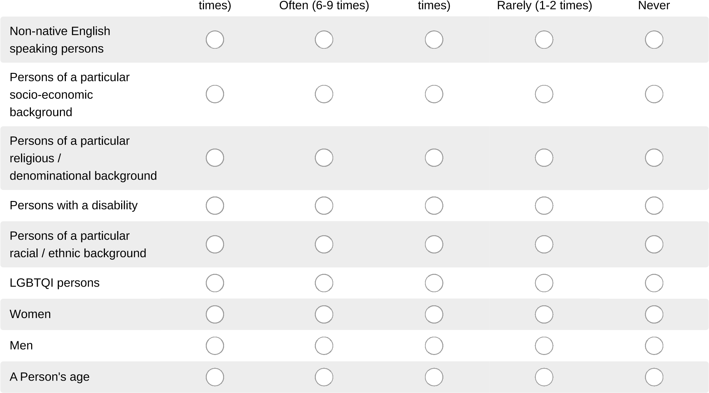
- Tell us how often THIS YEAR you have heard a FACULTY MEMBER OR TEACHING ASSISTANT in the MACO program make a disparaging or insensitive remark about:
Frequently (10 Occasionally (3-5

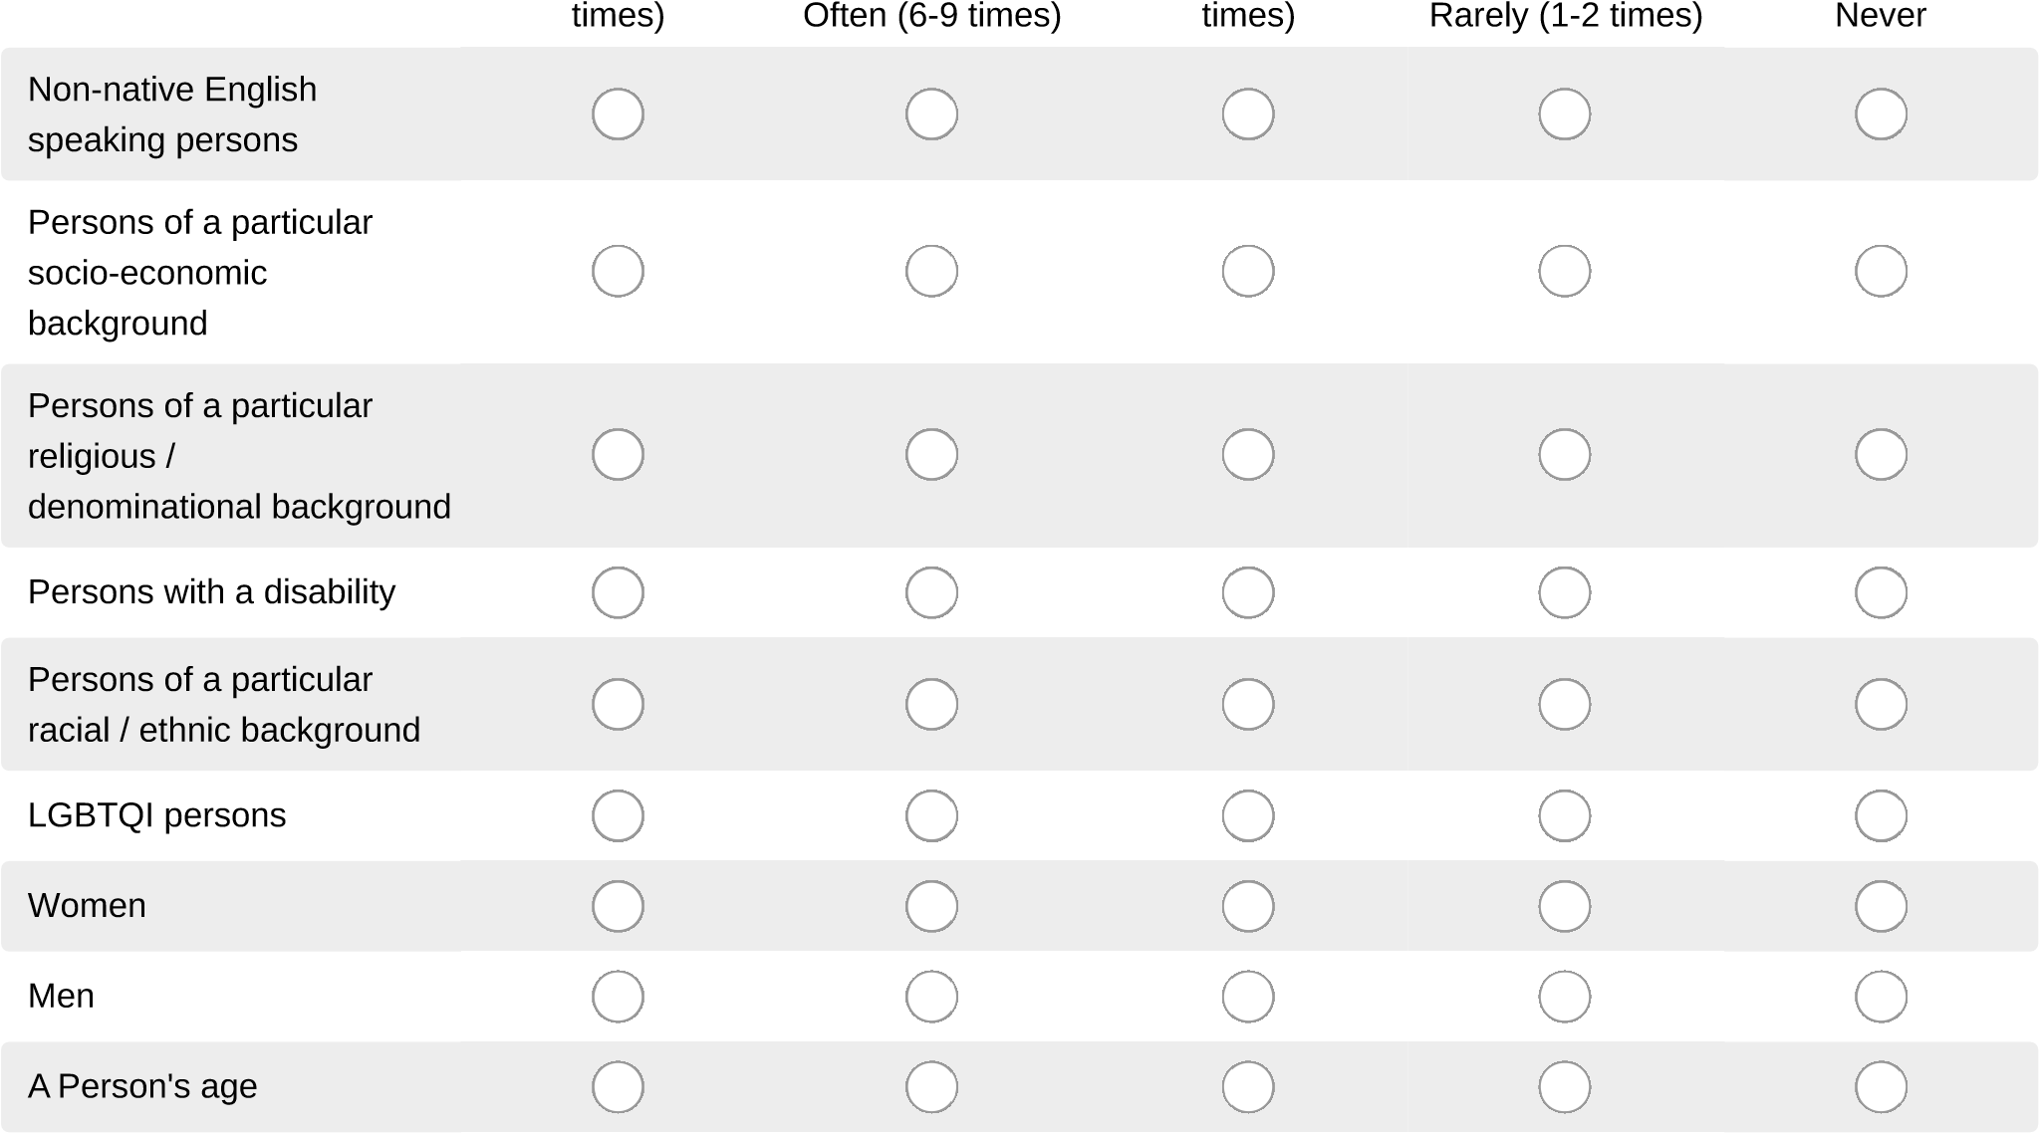
- Tell us how often THIS YEAR you have heard a STAFF MEMBER OR ADMINISTRATOR in the MACO program make a disparaging or insensitive remark about:
Frequently (10 Occasionally (3-5

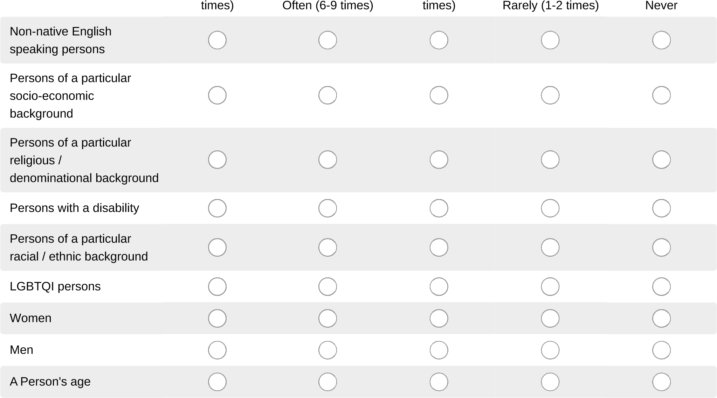
- How often THIS YEAR have you felt discriminated against or harassed in a MACO class or at a MACO event for the following reasons: (if you feel a category does not apply to you, please skip that item and add your own category in the "Other" box).
Frequently (10 Occasionally (3-5

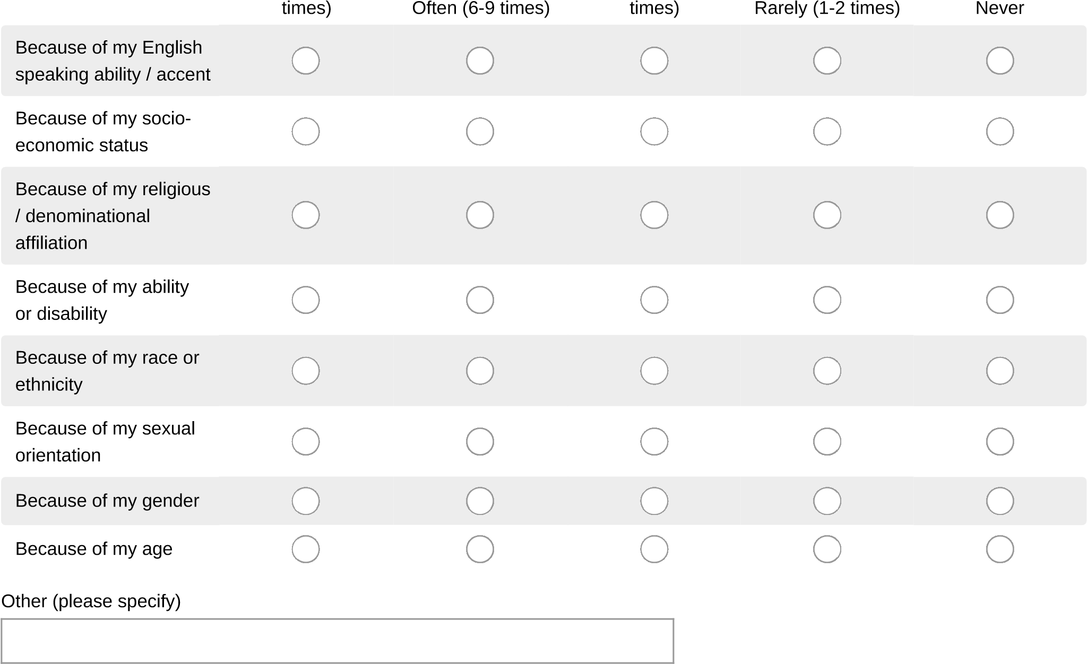
- In what form was the discrimination / harassment expressed? (Mark all that apply.)
Actual physical assault or injuryThreats of physical violdnet
Anonymous phone callsVerbal comments
GlancesWritten comments (including emails, messaging, website, etc.)
Ignoring
No discrimination or harassment experienced
- Where did the discrimination / harassment occur? (Choose all that apply.)
In a classroomVia the internet (website, Canvas, email, etc.)
In an officeNo discrimination or harassment experienced
While working at a campus job
- To which group did the person who was the source of the discrimination or harassment belong?
(Mark all that apply.)
AdministrationStudents
FacultyTeaching Assistant
Neighbors in the areaVisitors to campus
StaffNo discrimination or harassment experienced
- Please indicate your level of agreement that the MACO program adequately addresses issues on campus related to:
Not sure / Don't

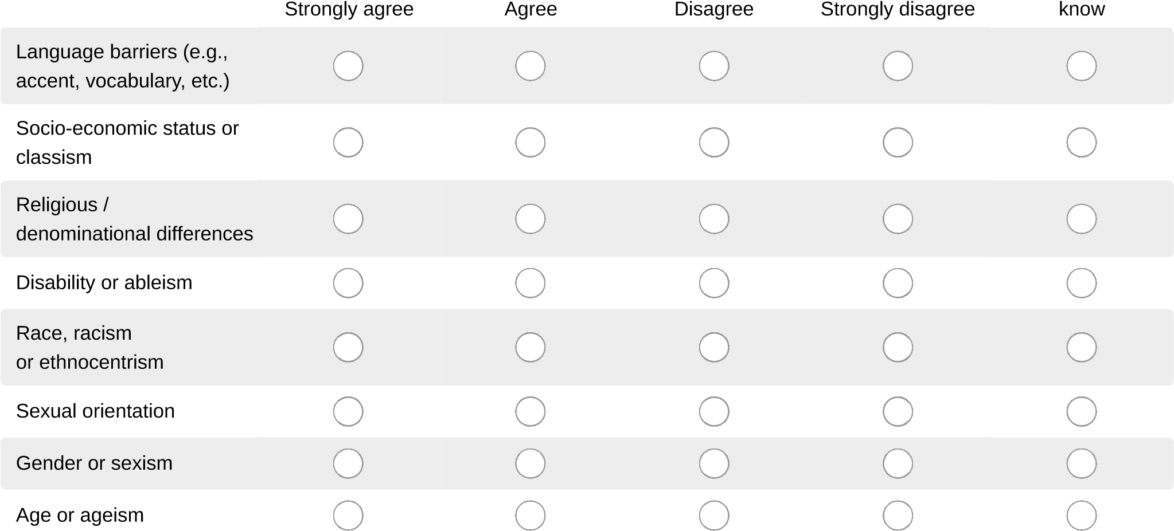
- Please indicate your level of agreement with the following statements about diversity in the MACO Hamilton program:
Not sure / Don't

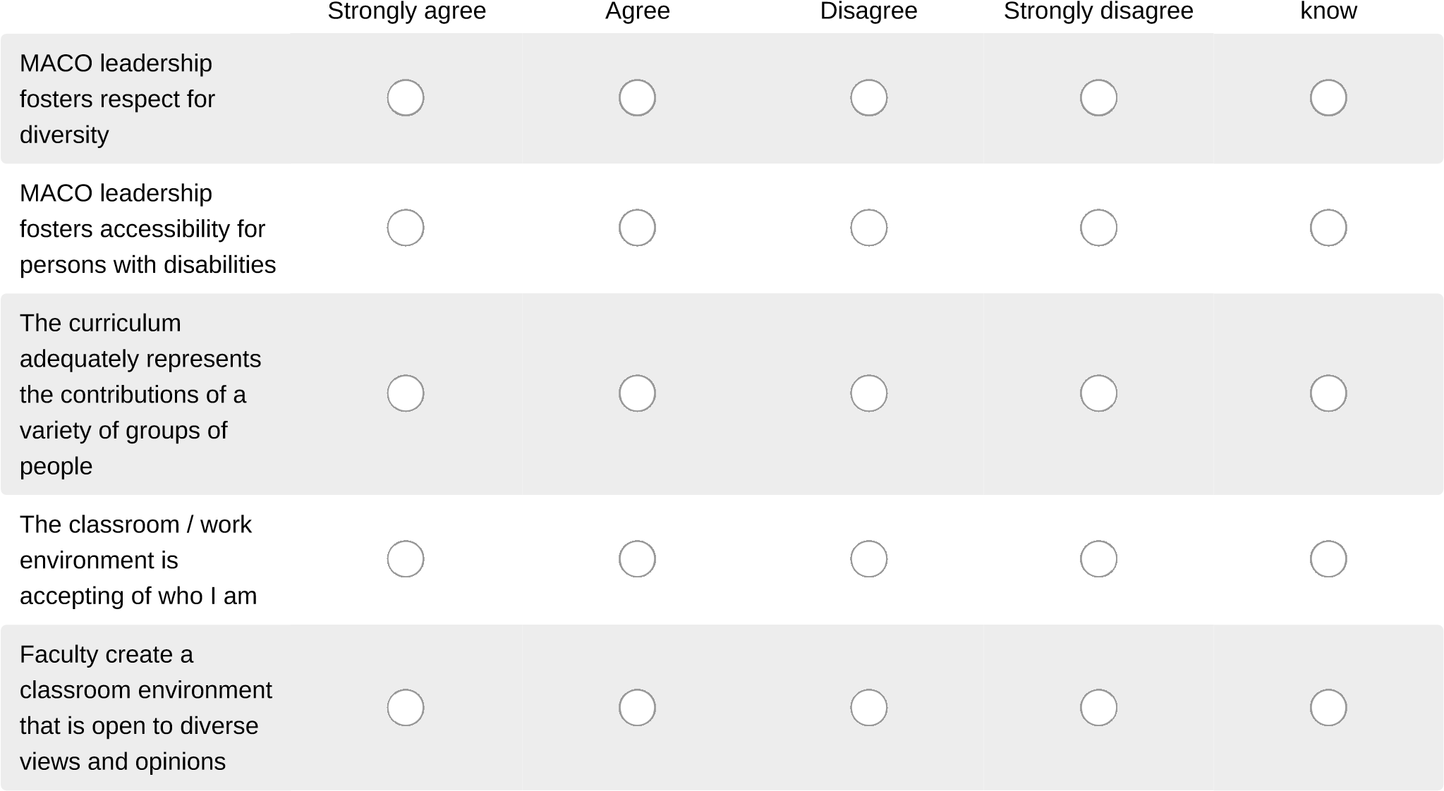
- Please indicate how likely you are to do the following: Not sure / Don't

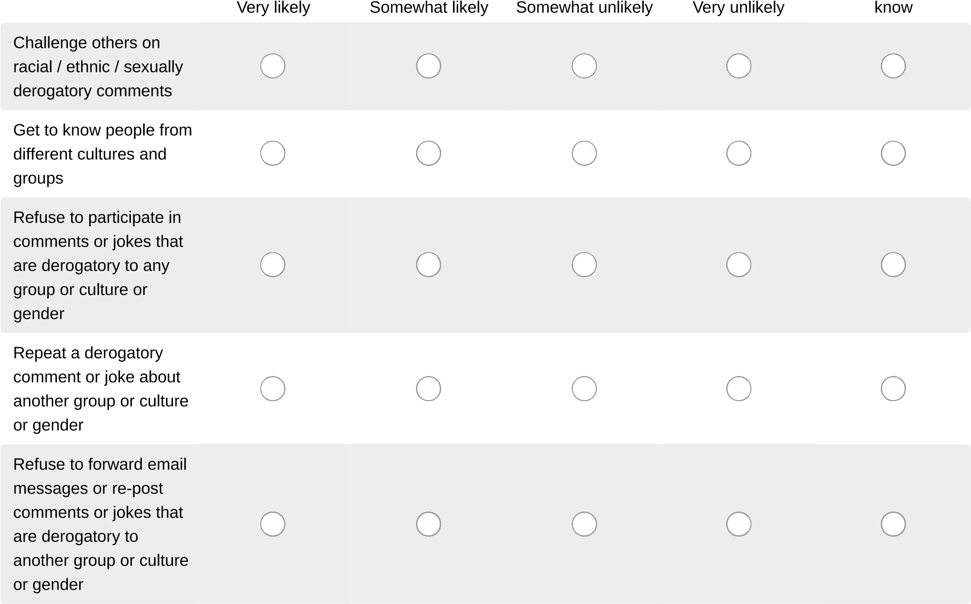
- Please indicate there primary racial / ethnic group with which you identify
 | African American or Black or of African Descent  Hispanic or Latino/a  Asian or Asian American  American Indian or Alaska Native |  | Native Hawaiian or other Pacific Islander  International citizen  White or Caucasian  Another race / More than one race

MACO Diversity Survey
As a member of a racial / ethnic / cultural group, please indicate your agreement with each statement.
- Please answer the following:

Yes
No
I have feared for my
physical safety on this
campus
I have had someone
assume that I was admitted / employed into the MACO program because I am a person
of color
I have been a victim of a
hate crime in the MACO
program because of my
race
I have received
adequate support in the
MACO program as a
person of color
- Please indicate whether you have experienced the following situations in MACO classrooms or MACO offices or in a MACO online class / meeting environment.

Yes
No
I have felt isolated or left
out when work was
required in groups
I have felt that I am
expected to present a
viewpoint that must be
different from the
majority
I have felt that I am
expected to speak on
behalf of all members of
my race or ethnicity
I have felt singled out for
my particular group
when issues of race or
ethnicity arose

MACO Diversity Survey
14. Do you identify as a sexual minority (e.g., gay, lesbian, bisexual, transgender, queer, questioning, intersex, asexual, aromantic, pansexual, non-binary, genderfluid, genderqueer, agender)? Yes
No

MACO Diversity Survey
15. As a person who identifies as a sexual minority, please answer the following:

Yes
No
In the MACO classes,
the topic of sexual
diversity is respectfully
discussed
I find there are safe
people in the MACO
program with whom I
can discuss my
sexuality
I can reach out for
support from a person in
the MACO program

MACO Diversity Survey
16. What disabilities do you currently have? (Please mark "No disabilities" if you do not currently have a disability.)
Coordination impairment
Mental health condition (which meets ADA criteria)
Mobility impairment
Visual impairment
Hearing impairment
Speech impairment
Learning disability
No disabilities
Other disability (please specify)

MACO Diversity Survey

As a person with a disability, please answer the following:

Yes
No
I have avoided
disclosing my disability
to a MACO instructor or
MACO administrator
due to fear of negative
consequences of
discrimination
I have been in a MACO
class / office / online environment where a professor or teaching assistant has regressed to make accommodations for my
disability
I have feared for my
physical safety in the
MACO program
because of my disability
I have been a victim of a
hate crime in the AMCO
program or MACO
online environment
because of my disability
I have received
adequate support from
the MACO program as a
person with a disability
Please indicate how you would rate the accessibility of the campus for you as a person with a disability in the areas specified below.
Does not

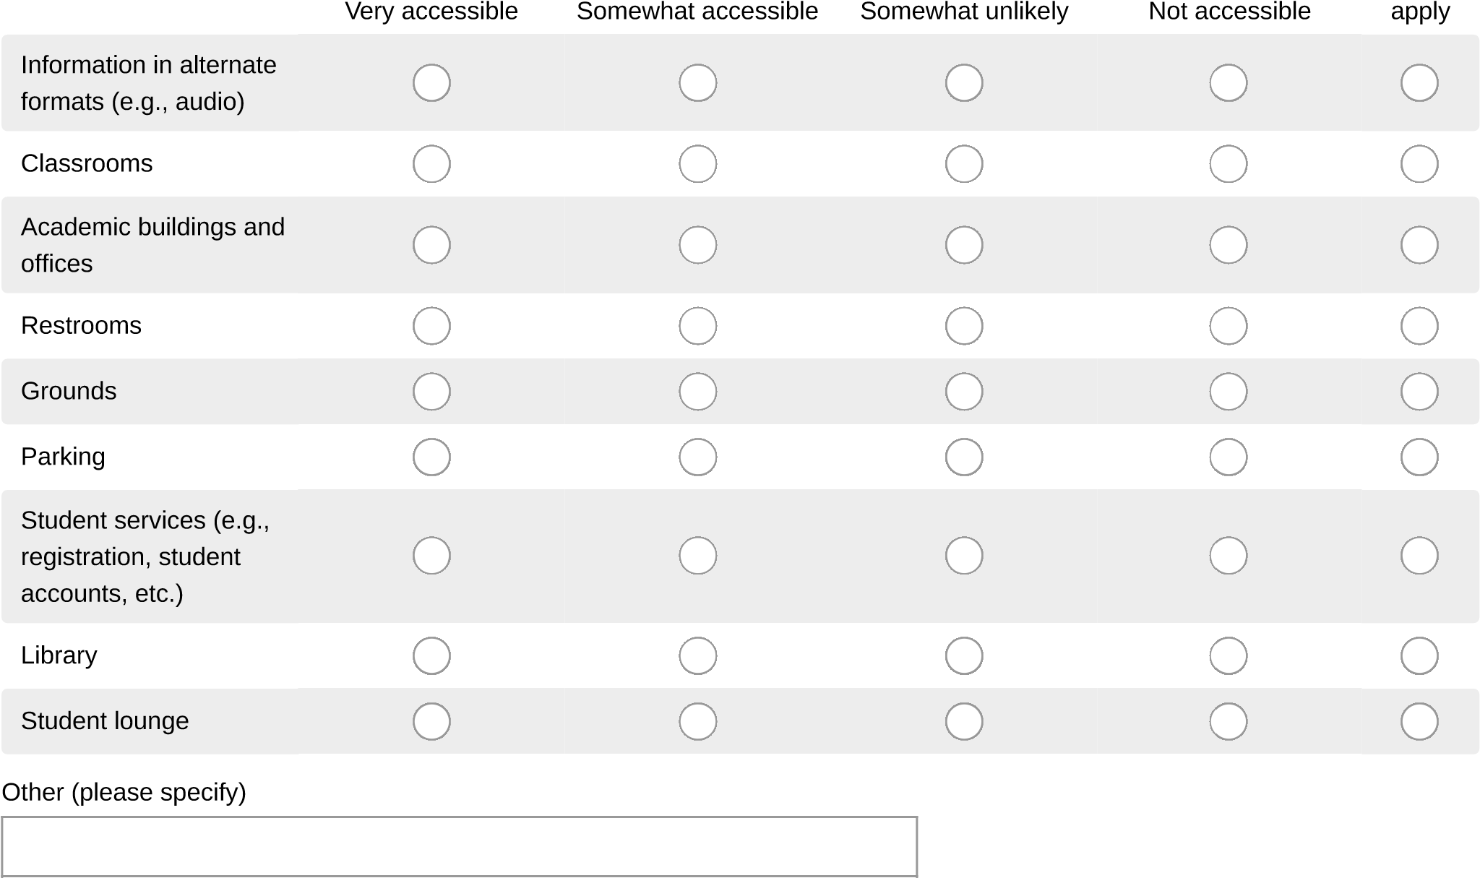

MACO Diversity Survey
Please indicate your level of agreement with the following statements:
Not sure /
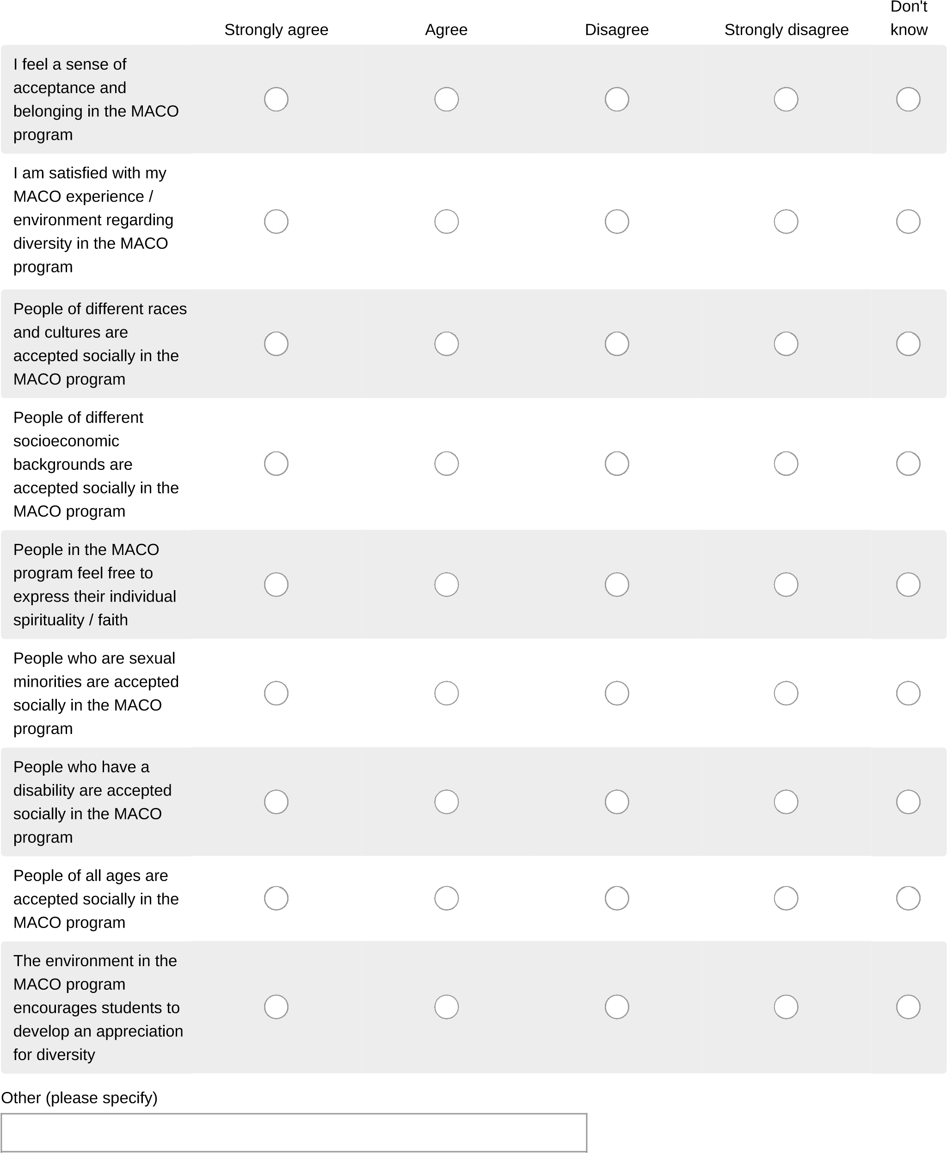
Please use the space below if you have experienced bias not mentioned in this survey, OR if you would like to offer your own suggestions on how the MACO program may move forward to improve the environment for people of diverse backgrounds.

- What is your status?
Administrator
Faculty
Staff
Student
- How would you identify your denomination?

- Are you a US Resident?
Yes
No
- Is English your native language?
Yes
No
- What is your gender?
Female
Male

