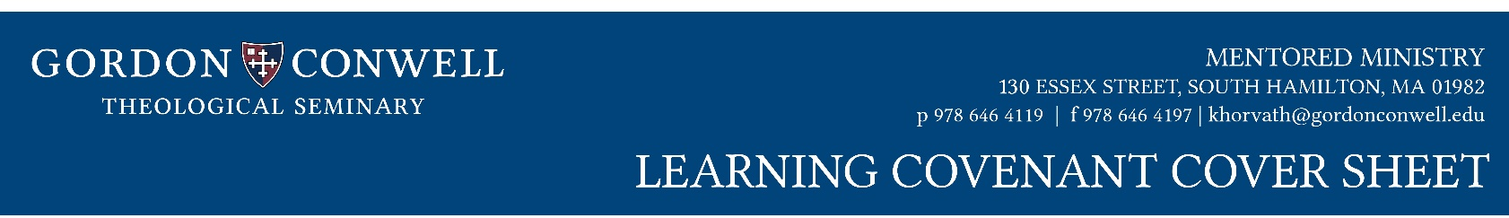

STUDENT INFORMATION

Full Name

_____________ ___ __________________
Student ID Degree Program

Local Street Address

_____________ ___ __________________
Telephone GCTS Box #

E-mail

MINISTRY INFORMATION

Name of Church or Ministry

Church/Ministry Address

Student’s Role or Title

Name of Mentor
Mentor GCTS Approved? Yes No

Mentor E-Mail

Mentor Telephone

What day do you meet?

What time do you meet?
Where do you meet?
Do you meet for: 1 hour every week
2 hours every other week

COURSE INFORMATION

Be sure to register via CAMS for each unit.
Learning Covenants (or Updates) are due each semester for field units.

Old program 96 units or New Program 90 units
MM505 MM605
MM705 Other

Semester (i.e. FA2022)

Starting Date for This Unit

Finishing Date for This Unit

Total Number of Weeks (minimum 12):
Total Number of Hours per Week (minimum 10,

includes 1 hour mentoring):

MINISTRY FOCUS (as applicable)

Educational Ministry Preaching
Pastoral Care Pastoral Ministry
Evangelism / Discipleship

AFFIRMATION

Student Signature Date

Mentor Signature Date

MM Director Signature Date

OFFICE USE
Student DB Mentor DB Memo Sent
Canvas DB

