THE PROCESS OF MENTORED MINISTRY

Before beginning your field work with Mentored Ministry,
you must be sure to do the following:
Take the Pre/Co-requisite SF/MC501-Spiritual Formation for Ministry (or SF/MC591-Dynamics of Spiritual Life). You must enroll in one of these courses prior to or concurrent with your first MM course (MM505).

Attend the two Required Orientation Seminars in your first semester (2 Sat. mornings at 3 hrs. each). The first semester gives you time to visit around and prayerfully find a home church and/or Mentored Ministry situation, as well as prepare you philosophically and practically to do your MM field units.
Setting Up Your Mentored Ministry Experience(s):
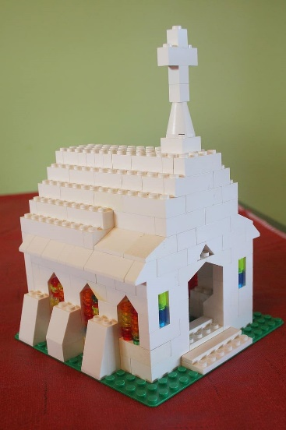

Ministry Selection(s). A significant range of ministry experiences are acceptable to the MM Department—from your home church, to nearby or city congregations, to parachurch ministries, summer projects, and overseas (OMP). Each unit must be at least 12 weeks long at a minimum of 10 hours per week, and your ministry role must not be primarily administrative or musical worship leading. If you have questions about the acceptability of a given ministry situation or mentor, contact the MM Office and we will be happy to assist you.

Mentor Selection & Approval. Talk with the pastor and/or potential mentor at your selected church or ministry site to explain to your Mentored Ministry requirement to them and your interest in ministry opportunities with them. Most pastors will know about MM and will be happy to let you know if they have space and ability to work with you. Some churches already have an established MM path for students to take which you may be able to plug right into.
Once you have selected your ministry situation make sure that your selected mentor is GCTS approved. Minimum requirements for mentors are five years of full-time ministry experience. Once approved, mentors must attend the next scheduled New Mentor Orientation (NMO) in September in person and/or via Zoom. If your mentor has mentored GCTS students before, they can tell you if they have already been approved and/or attended the NMO. If you’re unsure if they have been approved, you can also ask the MM Office about their status. If they are qualified but not yet formally GCTS approved, invite them to use our Application to Mentor to apply. The MM Office will work with them to arrange for their subsequent approval and orientation.

Register for MM. Register in Sonis for your Mentored Ministry course(s) during the semester(s) that you plan to formally do them – the same way you would for any classroom course. Please don’t forget!

MM courses may be registered for and embarked upon in the Spring semester (Jan.-April), Full Summer term (May/June-August) and Fall semester (Sept.-Dec.). Any “off-schedule” Mentored Ministry (i.e. commencing not during the regular bounds of the semester) may only be arranged through the MM Office (AC233, mmassist@gordonconwell.edu, 978-646-4119).
Serve in your Mentored Ministry!
Serve the Lord with gladness! (Ps. 100:2)

Remember that there are assignments due at the beginning and end of each term you’re registered for an MM course. In addition, there are monthly 1-hour reflection groups that you must participate in with Dr. Horvath and your fellow MM students (explained/announced in Canvas once you register).

